ABLEKUMA CENTRAL MUNICIPAL ASSEMBLY
ENVIRONMENTAL HEALTH AND SANITATION UNIT
SENSITIZATION AND EDUCATION TO FOOD HANDLERS ON FOOD SAFETY, STORAGE, PACKAGING AND PERSONAL HYGIENE FOR FIRST QUARTER, 2023 (23RD FEBRUARY-20TH MARCH)
INTRODUCTION
Food safety is fundamental in food businesses, as it ensures the protection of consumers from potential health risks and upholds the reputation and success of the industry.
All human need food to survive. The nutrients we get from consuming food give us the energy and nourishment we use to sustain our daily activities.
This aspect of the food supply aims to protect customers from food poisoning and foodborne illnesses affecting human life.
The concern for the integrity of food safety remains within all parts of the food supply chain. The food safety production life cycle starts from agriculture to the packaging of finished products and delivery to the consumers table.
Food safety is essential to provide adequate access to safe, nutritious, and delicious food to all members of the community.
Recent data and food safety news released by the World Health Organization have estimated that at least 600 million people all over the world become inflicted with foodborne infection after consuming unsanitary food.
OBJECTIVE
- To protect consumers of food products from foodborne illnesses or injuries related to food.
- To increase the knowledge of food venders on food safety issues.
- To improve their knowledge on food handling practices that can be applied to keep food products wholesome.
ACTIVITY
During the second quarter, the Environmental Health and Sanitation Unit in collaboration with traditional caterers’ association organized training to food venders on food safety; storage, packaging and personal hygiene.
The training took place in zongo, Town council line, Mataheko, Mambrouk Park, Adwebu, Russia and Abossey Okai. They were educated against cooking in the open spaces, avoid storing raw food on the bare floor, not to mix raw food and cooked food to store in a fridge.
They were advised to use improved stove and gas for preparing food to reduce pollution by smoke from their activities.
In terms of packaging, they were advised not to package hot food in rubber or take away bags rather go back to the traditional leave system.
They were also taken through personal and body hygiene among others.

Picture gallery
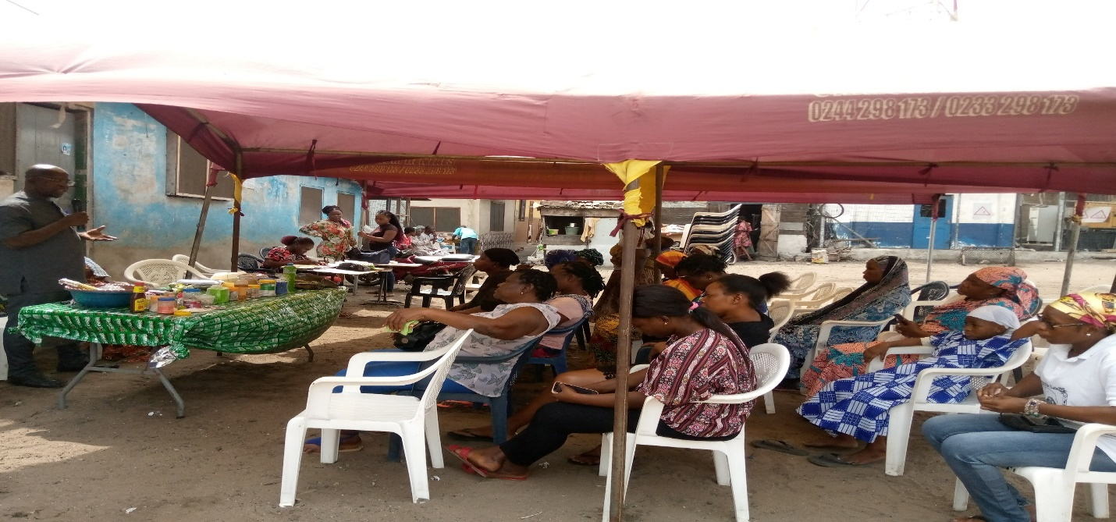

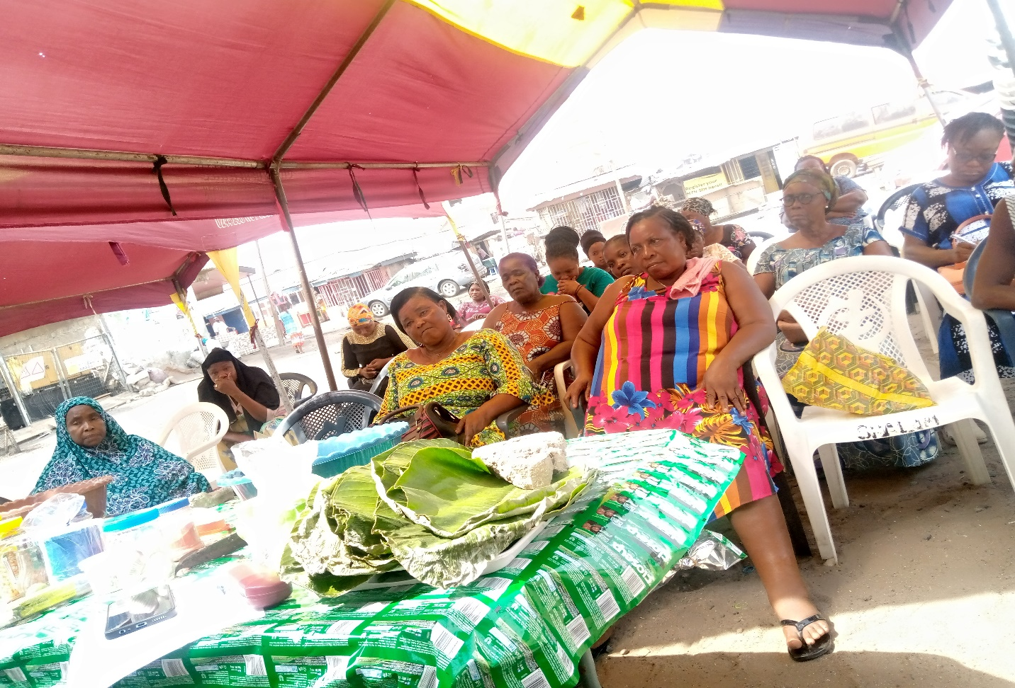

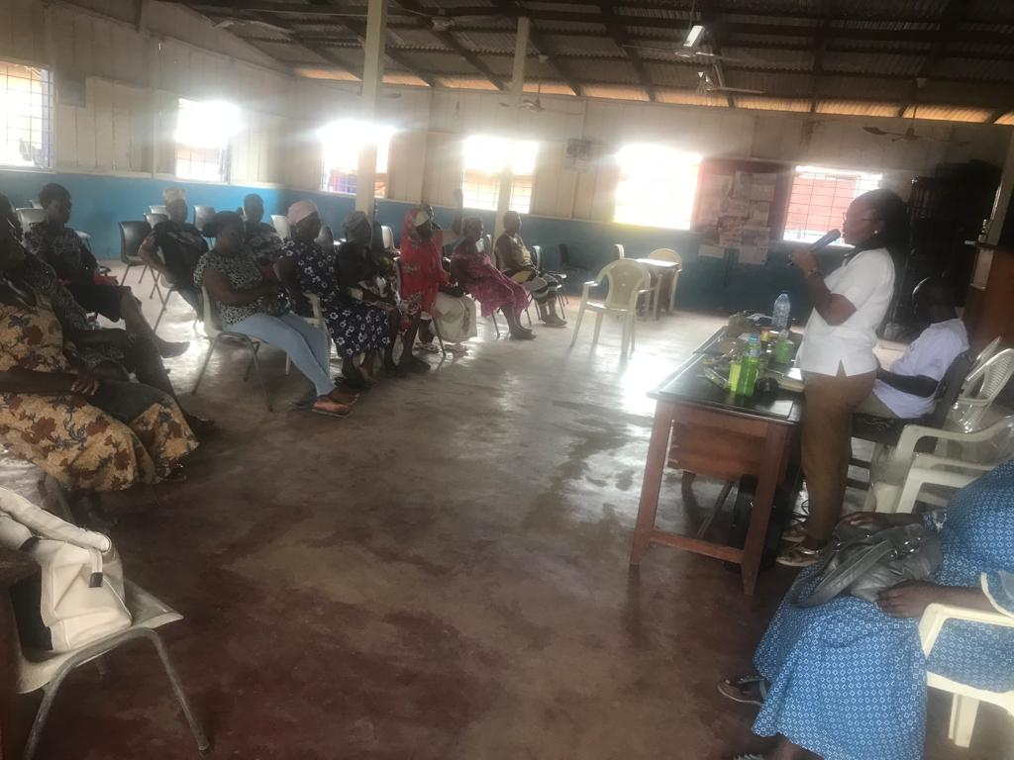


CONCLUSION
Activity was successful and highly participated by food venders.

Compiled By:

Bridget Seyram Diapim
(Municipal Environmental Health Officer)

